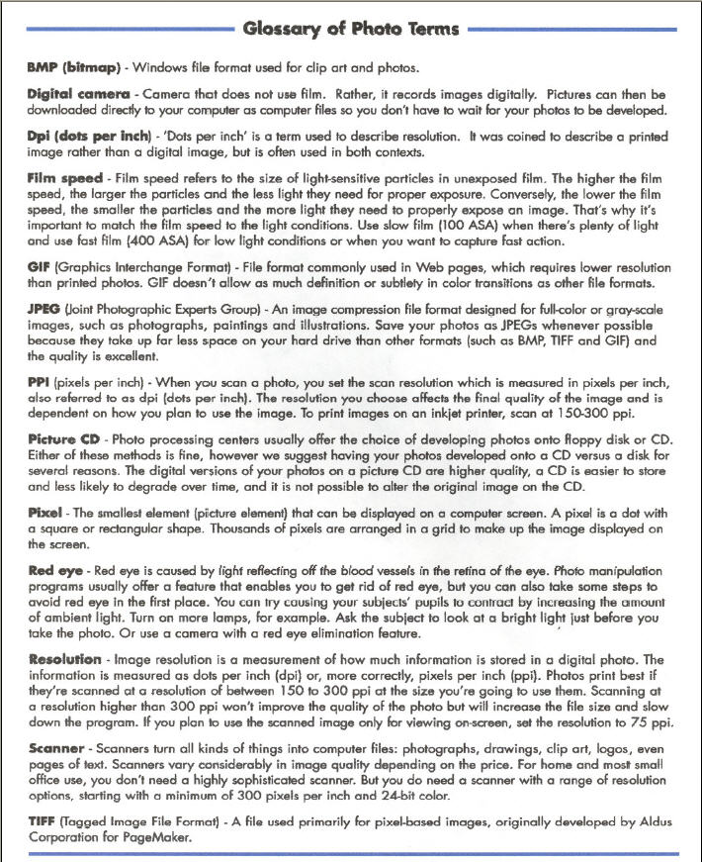

www.instantreality.net

